Valencia City Parks Department

Virtual Server Configuration and Maintenance Manual

Prepared by

Team 3 Technologies, LLC

Technology • Consulting • Design



Table of Contents

Introduction 1

Our Mission 1

About Us 1

Services and Licensing 2

Chapter 1. System Requirements 3

Determining System Requirements 3

Microsoft Distribution 3

Microsoft Server 2016 4

Processor (CPU) Requirements 4

Memory (RAM) Requirements 4

Storage Requirements 4

Network Adapter Requirements 4

Linux Distribution 4

Linux Ubuntu Server 18.04 5

Processor CPU Requirement 5

Memory 5

Storage Requirement 5

Network Adapter Requirements 5

Applications 6

Windows Server 2016 (with Active Directory) 6

Security Applications 6

Team Viewer 6

TreeKeeper 6

ActiveWorks 6

Chapter 2. Cloud-Based Installation 7

Before You Begin 7

Step-by-Step Installation Instructions 7

Additional Resources 25

Chapter 3. Microsoft Server 2016 Installation 26

Before You Begin 26

Installation 26

Chapter 4. Maintenance and Security 33

Routine and Preventative Maintenance 33

Scheduled Maintenance 33

Increased Security 33

# Introduction

**Team3Technologies, LLC (TCT)**, is proud to have collaborated with City of Valencia’s Parks Department in the creation of their virtual server and this related documentation. We hope to continue working with the City to support our community, now and in the future.

## Our Mission

In short, we focus on process and cost efficiency through the deployment of technology and design.

Whether your business needs software support for rebranding or logo redesign, a virtual server installation or a total network audit and overhaul (software and hardware), we are ready to rise to the challenge. Our staff stays up-to-date on the latest industry trends and trainings. In fact, they are all currently attending related sessions at Valencia College.

## About Us

Founded in mid-2019, T3T is comprised of four individuals who are passionate about finding innovative ways to bring efficiency and savings to our customers through the use of technology.

T3T is an Equal Opportunity Employer and is proud to report a 0% employee turnover rate since inception. The following individuals are the founding members:

**Ms. Adenike “Nike” Adeyemi** was raised in Chicago but spent childhood summers in Charleston, North Carolina. She plays the violin, likes Italian food and has an iguana named “Gerald.” Her professional interests include computer programming and forensics.

**Mr. Iftikaar “Ifti” Ahmad**, once an Olympic gold medalist in badminton, is also an avid collector of coins, stamps, and dusty records. His greatest fear is not knowing what Gordon Ramsay’s cooking tastes like before he dies.

**Ms. Ashlyn Kutik** prefers not to divulge any personal information. And that’s not her real name.

**Mr. Jeremy Fristoe** never really got over the cancellation of Firefly. He has been to flea markets in twelve countries, but returned empty-handed from each. If he had one wish to make, it would obviously be for a thousand more wishes.

It is also worth noting that **Mr. David Brunick** played a crucial role in introducing us, the team members, and helping to bridge the gaps which lay between us and our endeavors. For that, we will always be grateful.

## Services and Licensing

This manual has been created specifically for your agency, to assist with the installation of one or more virtual servers. The specifications discussed in this guide assume no more than 125 persons will utilize this system at any given time. If the amount of system usage increases or decreases significantly over time, it may be prudent to have your technological needs reassessed by Team3Technologies, LLC.

The services which are described in this manual have been provided by T3T and are intended to be used by Valencia City Parks Department. The methods used and discussed assume VMWare installation, or that of a similarly compatible software package. T3T has provided for the co-residency of certain applications on Linux- and Windows-based operating systems within this virtualized environment.

The services which have been provided are licensed as an initial consultation and deployment, with optional add-on features, training and equipment available in the future.

# Chapter 1. System Requirements

## Determining System Requirements

System requirements for virtualization can vary greatly depending upon how the machine is going to be used. At a bare minimum it is required that any machine being used for virtualization be able to support an operating system (OS). This means that adequate memory, storage, and networking capabilities must also be taken into consideration for provisioning of a virtual environment. Different operating systems have minimum specifications which are listed later in the chapter.

For the purposes of this manual we will be showing how to implement both a Microsoft Server 2016 and Linux Ubuntu Server 18.04 OS using Microsoft Azure. Both operating systems are cloud-based orientations but can also be implemented with an on-sire setup.

## Microsoft Distribution

Microsoft Server 2016 is an operating system similar to that of Windows with the added capabilities of increased control over almost all aspects of operation. Within a business environment it is essential to have security, cost effectiveness, as well as familiarity so that everyone is capable of using the system. Active Directory which is the center of Server 2016 is an added feature that allows the increased control over the running of machines. It is recommended to hire a specialist to set up this feature specific to your business needs. We at T3T also provide this service for an added cost (contact for more info). In order to have a virtual machine running Server 2016 we will begin by using Microsoft Windows 10 as our base operating system.

The specifications for Microsoft Windows 10 are listed below:

* **Processor:** 1 gigahertz (GHz) or faster processor or SoC
* **RAM:** 1 gigabyte (GB) for 32-bit or 2 GB for 64-bit
* **Hard disk space:** 16 GB for 32-bit OS or 20 GB for 64-bit OS
* **Graphics card:** DirectX 9 or later with WDDM 1.0 driver
* **Display:** 800 x 600
* **Internet**: Connectivity is necessary to perform updates and to download and take advantage of some features.

**\*Note**: UPDATES ARE REQUIRED FOR CONTINUED SUCCESSFUL OPERATION OF VIRTUAL ENVIRONMENT.

### Microsoft Server 2016

Once we have a base operating system installed on all devices, we can begin the setup of the virtual environment. In order to have Microsoft Server 2016 with Active Directory as the operating system for the virtual environment specific requirements need to be met:

### Processor (CPU) Requirements

One of the major components that affects the system performance is Processor. The performance of a processor depends on the various CPU factors. Windows Server 2016 requires the following minimum processor requirements:

* The processor should have at least a 1.4 GHz speed.
* The platform of the processor should be based on 64-bit architecture.
* It should support Second Level Addressing technologies.

### Memory (RAM) Requirements

Along with the processor, memory is also one of the major factors to decide the system performance. Windows Server 2016 requires at least 512 MB of RAM. The RAM should also support the ECC (Error Correcting Code) feature.

### Storage Requirements

Microsoft suggests minimum 32 GB of free disk space for Windows Server 2016. However, you can install it on a disk having the less free space. Keep in mind, the disk space requirement also depends on the size of RAM of your system. More RAM memory means more disk space will be required for paging, hibernation, and dump files. It is also recommended to use a SSD as this will increase the speed of computing operations.

### Network Adapter Requirements

The network adapter for Windows Server 2016 should meet the following requirements:

* Should have at least the gigabit bandwidth
* Should be compliant with the PCI Express architecture
* Should have the PXE boot capability

## Linux Distribution

Linux Ubuntu Server 18.04 functions similarly to Ubuntu Desktop. The major difference is that Ubuntu Server does have the X11 process. This means there is no graphical interface and only the terminal can be used. It’s important that when deciding to use Ubuntu Server 18.04, that the administrator is well versed in using the Linux terminal as that is where most time will be spent when maintaining the server. It’s recommended that when running the virtual machines, you do not run no more than ten virtual machines in one server if you want to maintain adequate performance.

The minimum specification to run the host server:

* Processor: 1 GHz 64-bit processor with Virtualization enabled (required)
* RAM: 2GB 64-bit
* Hard disk Space: 6GB
* Internet: There needs to be an internet connection make updates

### Linux Ubuntu Server 18.04

Installation of the Linux server is very simple. One must just need to download the disk file from the Canonical website. However, there are certain conditions that must be fulfilled in order for virtualization to be possible.

### Processor (CPU) Requirements

This is part is required to make virtualization possible. The processor MUST be able to handle 64-bit processing and it MUST have support for virtualization. AMD-V and Intel-VTx processors are examples of these processors. The following are minimum requirements to run the server:

* Minimum of 1GHz
* One core for each guest OS

### Memory (RAM) Requirements

There must be enough memory to run the server to not only run properly but also allow the guest OS to run properly as well. It must also be able to user error code correcting. The minimum recommended RAM space is 2GB for the base server plus the amount of RAM to allocate to the guest systems. And since this is a server it’s important.

### Storage Requirements

Needs at minimum 6GB of space to run the base server. According to redhat, the recommended amount of space needed for a guest system is the following equation:

**raw format total >= space for guest images + space for memory swap + space for host server**

If creating a qcow disk image:

**qcow format total >= (space for guest image * 1.01) + space for memory swap + space for host server**

### Network Adapter Requirements

A network adapter for the host machine is required if you want to create a bridged network between the virtual machine and the host server. Ubuntu Server will support most PCI and PCI express cards and older ISA cards. They can also support ISDN cards.

## Applications

Below are some of the applications which can be deployed on your server(s).

### Windows Server 2016 (with Active Directory)

Active Directory is a hierarchical database that keeps track of user accounts, computers, certificates, security policies, and other resources in a computer network, before AD from single point location. AD can keep information about organizations, sites, systems, users, shares, and many other things, so AD is more flexible than a phone book, but the concept is similar. One significant difference of AD is that it saves objects in a hierarchical order, and all objects are unique. that’s why a domain name is required when installing AD, all objects in a domain forest are “sub domain” or children of the top domain. AD is a very complex system and understanding it takes time and a lot of hands on experience. A lot of the things systems administrators do involve AD whether it could be either group policy, permission access management, LDAP authentication, etc.

### Security Applications

Norton Antivirus is an anti-virus and anti-malware software product developed and distributed by Symantec Corporation. It uses signatures and heuristics to identify viruses. It or any other product similar is needed to ensure a secure system.

### Team Viewer

TeamViewer is a popular piece of software used for Internet-based remote access and support. TeamViewer software can connect to any PC or server, so you can remote control your partner's PC as if you were sitting right in front of it. For the remote session to work the partner has to start a small application, which does not require installation or administrative rights. You are able to work within the other PC and even drag and drop different things onto remote PC.

### TreeKeeper

TreeKeeper is the pioneer resource management software in our industry and continues to evolve to meet the changing demands of this field. Whether you are in the office or out in the field, coordinating and planning work with your internal crews and outside contractors, or providing benefits information to the public, TreeKeeper is a user-friendly and versatile tool that can easily access and manage your data from any location with an internet connection. You are able to add inventory data and edit fields on the fly using any internet connected device. You can also assign user permissions along with integrate popular third-party tools like Cityworks or 311.

### ActiveWorks

ACTIVE Works technology is a best in class, highly scalable cloud platform. Secure, stable, and flexible, ACTIVE Works provides services and infrastructure to support organizations of any size. ACTIVE Works offers integrations for third party services, such as social media and CRM solutions and they also offer extensive reporting capabilities. As with all ACTIVE Network products, our data center provides our customers with a high degree of reliability, protection and scalability. The data center offers 24/7 monitoring and even some self-healing capabilities.

# 

# Chapter 2. Cloud-Based Installation

## Before You Begin

This section provides instructions for deploying your server **within a virtualized cloud environment**. It may be a good idea to perform the following actions prior to beginning the installation:

* Double-check system specifications and adhere to the noted requirements mentioned in **Chapter 1: System Requirements**.
* Back up all data!
* Review step-by-step installation details prior to starting.

## Step-by-Step Installation Instructions

A cloud hosting account is required. In this setup for a LINUX based operating system, we will be using Microsoft’s Azure.

1. On the home page, click on the **Virtual Machine** service at the top page.

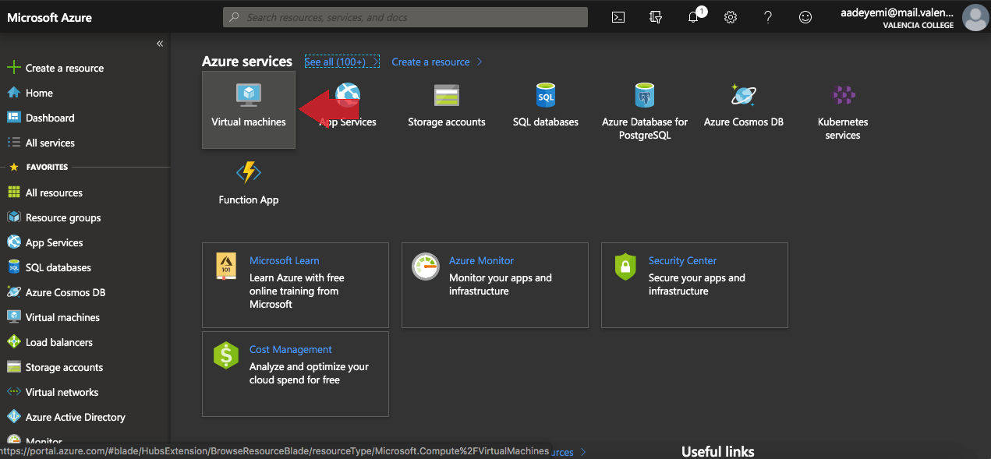

One can also reach the Virtual Machine service by clicking **Virtual machines** on the left side menu or clicking on **All services** and searching for Virtual Machines.

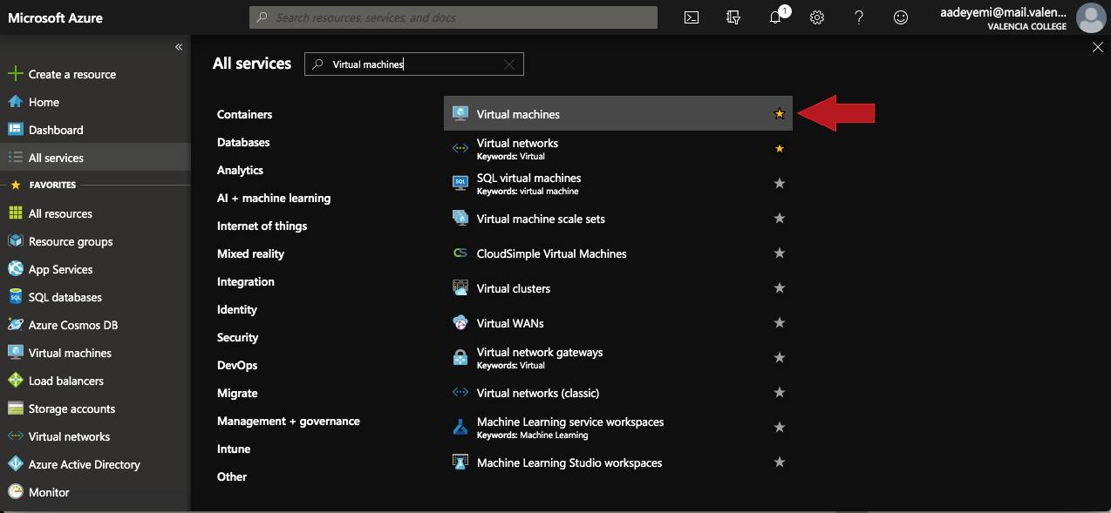

1. If you are new to Azure then the list of VMs should be empty. Click the **Add** button on top to begin creating a virtual machine.

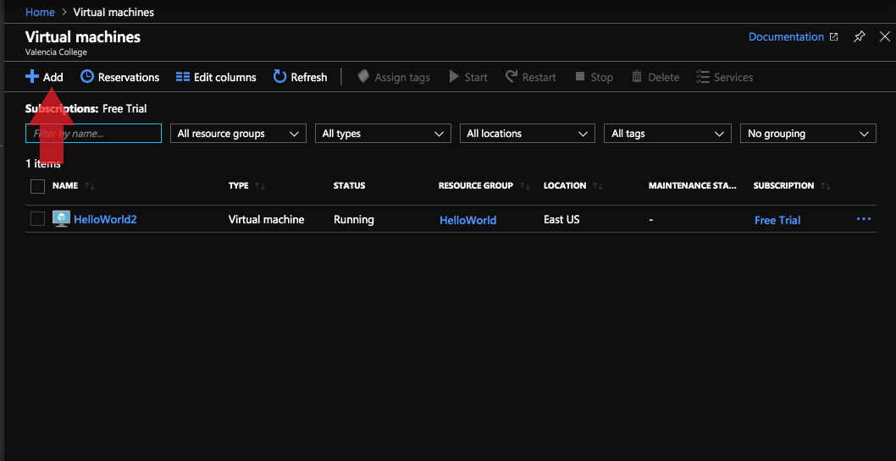

1. From here, you will specify the basic configuration of the machine, such as operating systems and admin account. First, you must specify which subscription plan will be attached to this VM. This will further specify which resource will go with this VM, as well.

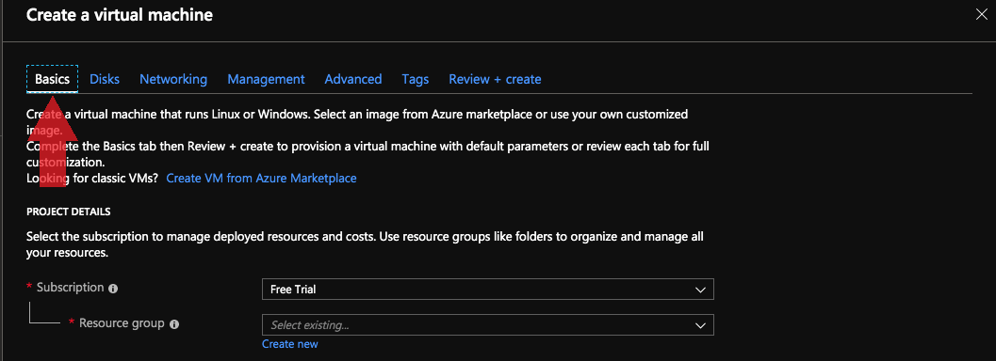

If there are no resources available, you can create a new one by clicking the **Create new** link under the resource input box.

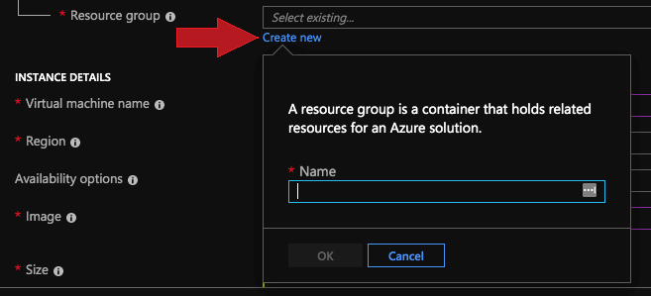

1. Next will be the actual details of the Virtual Machine. In the first box, you will specify the name of the virtual box. This will become the host name of the Linux Server. Next, you’ll specify the region for this server. Ideally, you’ll want your server to be located where most of your users will access it. Then, you would specify the Image of the operating system you would like to install. In this example, we’ll be installing an Ubuntu Server 18.04 LTS.

Next, we’ll specify the size of the machine, such as the CPU, RAM, Storage, and the price. Pick a size that caters to your purpose and price range. You can change this later, after VM creation. For virtualization purposes, The D2 series is the best place to start.

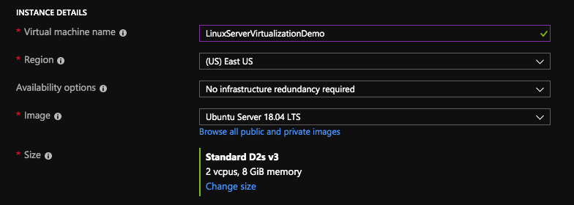

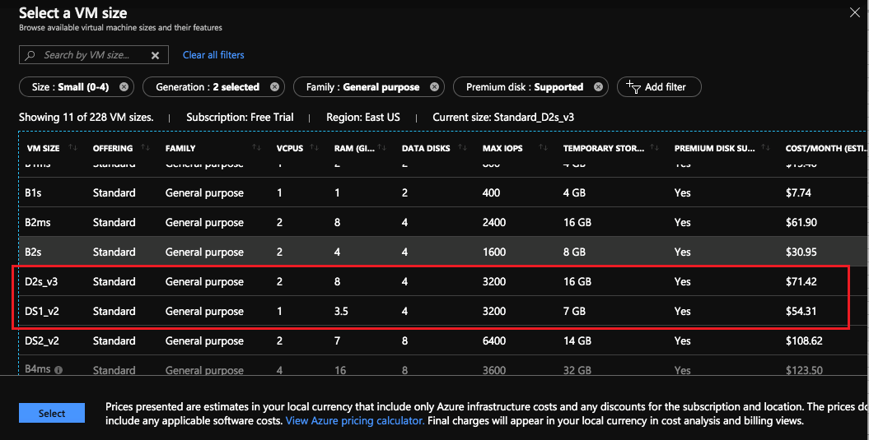

1. Next, an administrator account needs to be created. Unlike Windows, Linux has the option to create an SSH login rather than a password login, or to have both. One just needs to generate an OpenSSH style public key. If you plan on using a console like ttyS0 to access the server then use **Password** type authentication.

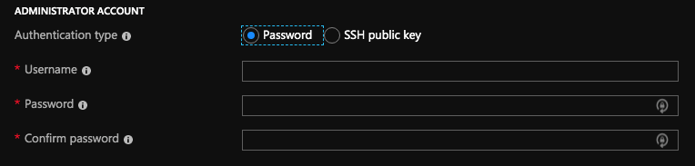

If you plan on using SSH then use **SSH public key** type. You can later configure the account to have both SSH key and password.

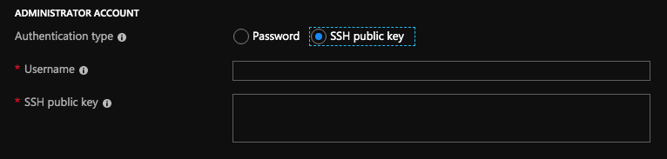

1. For the final part of the basics section, inbound port rules need to be configured. You have the option to allow HTTP, HTTPS, SSH, RDP or none at all. If using SSH, log into server and make sure SSH is available. Again, these settings can be changed after server creation.

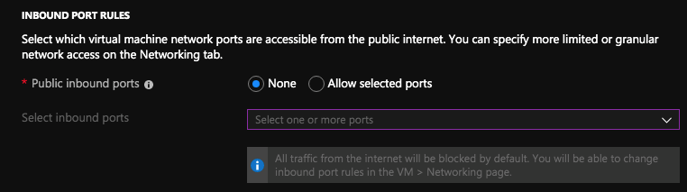

1. At this point, your VM is ready for creation, as the bare minimum requirements have been fulfilled. Click on **Review + create** to jump to the end step of the creation process.

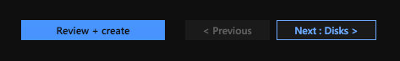

1. Azure will check your settings to make sure everything is configured properly. If a check mark appears on top, everything was set up correctly and you’re ready for deployment. Use this time to review your settings and make any last-minute changes.

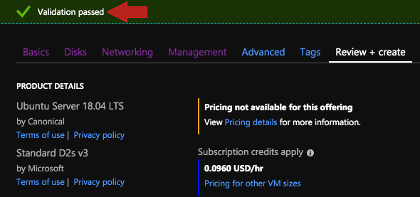

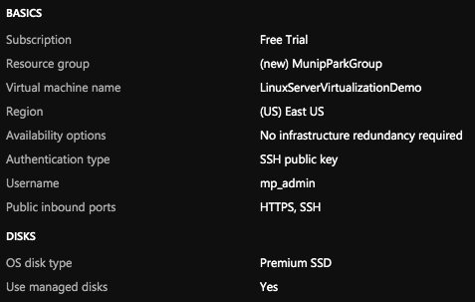

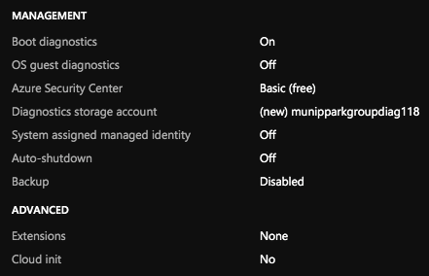

1. Click on **Create** to begin deploying the VM. It will take a few minutes to finish.



1. You should see this screen when your server has been deployed successfully. Now it’s time to prep the server for virtualization. A console with a terminal emulator will be needed for the following steps. If you have a Mac or Linux, Terminal will be just fine. Windows can use Putty. Azure recommends downloading the Azure CLI or using Azure Shell to log in. Use whatever you are comfortable with.

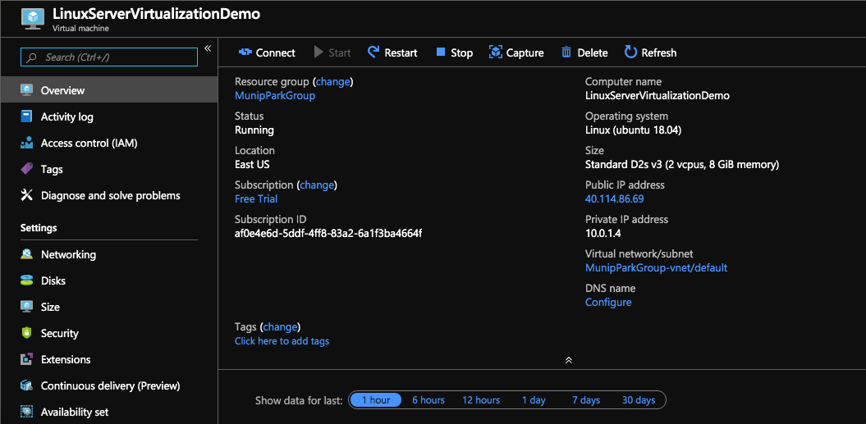

1. Click the **Connect** button. This will tell you the information needed to log into your server using either SSH or RDP. In this example, I will use SSH to log in.

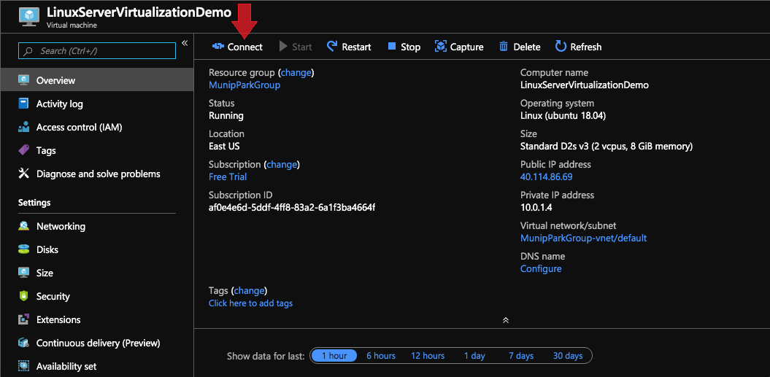

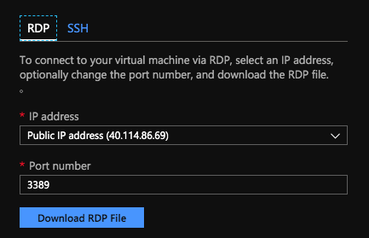

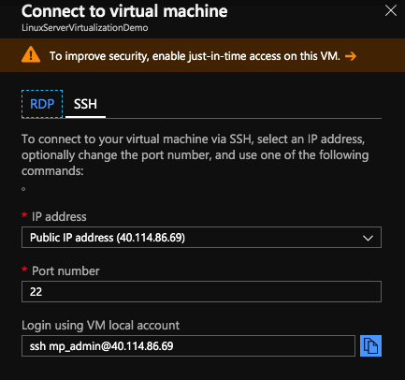

1. Log into the server with your method of choice.





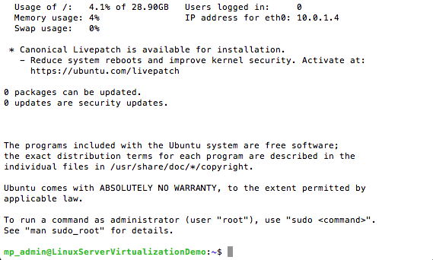

1. It’s optional but feel free to make a backup of the server at this point on Azure. That way, if a mistake is made during installation, you can return to the original state before the damage was done instead of redeploying a new VM from scratch.
2. Update the Server using sudo apt-get update and sudo apt-get upgrade.

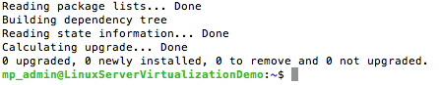

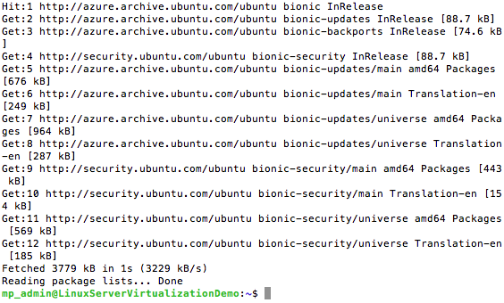

1. Now we need to make sure the server is capable of Virtualization. Run the command egrep -c ‘(vmx|svm)’ /proc/cpuinfo. If the number is greater than 0 then you will be able to move on. Else You may need a larger size VM.



1. Next, we need to check if the Linux server is able to run a KVM. You do this by using the kvm-ok utility which is a part of the cpuChecker dependency. Download it using the command sudo apt install cpu-checker.

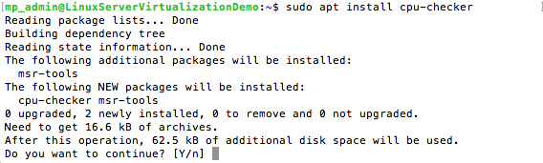



1. Now that we know the server is able to handle KVM, we now download the kvm and all of its dependencies using sudo apt install qemu qemu-kvm libvirt-bin bridge-utils virt-manager.



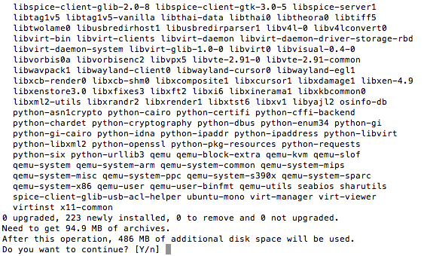

1. Make sure the admin account is added to the libvirt and kvm group by using the command sudo usermod -aG kvm, libvirt username.
2. Restart libvirt with the command sudo service libvirtd restart. Then run sudo service libvirtd status to make sure the daemon is active with no issues.

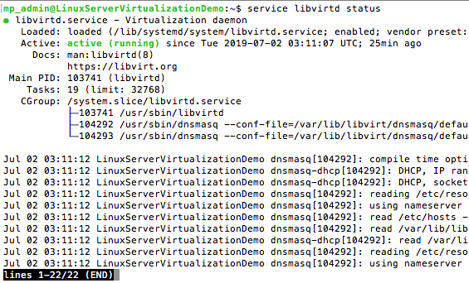

1. Use the command virsh -c qemu:///system list to make sure everything is installed correctly.

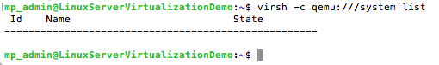

1. Now it’s time to create a disk image. First use ifconfig to bring up a list of network interfaces. With Azure, there should be an interface called for a bridged network. In my setup it was **virtbr0**. This will be the network bridged used for image creation.

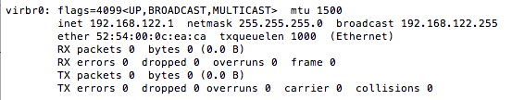

1. Enter qemu-img create to create a disk image. In this example qcow2 format image is created with a size of 4GBs.



1. Next, install the operating system using the virt-install command.  
   If you don’t have an iso, you can use the mirror site <https://launchpad.net/ubuntu/+cdmirrors> to download the ubuntu iso directly. Here, I used Princeton.edu to download the iso.

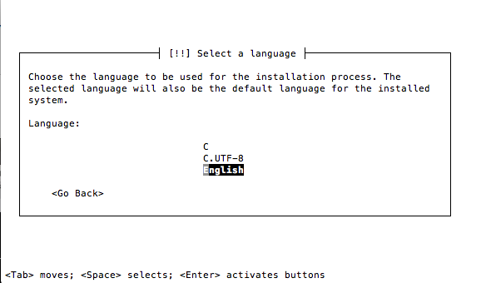

1. If done correctly, the Ubuntu installation will begin. Just follow the instruction and complete the installation process. Make sure to at least Open **SSH** in order to make an SSH connection to the virtual server. The process ends when it restarts itself. The screen will then go blank and its serial interface is not enabled.



1. Use CTRL + SHIFT+ [ or CTRL + [ to go back to the terminal. If these commands don’t work, close out the terminal and log back into the Azure server.
2. Use the command virsh -c qemu:///system list. If the name of the machine you created is on the list and running, then you know the installation was a success.

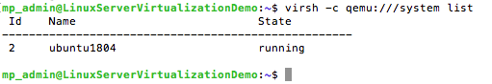

1. Now we need to get the IP address of the newly created machine. Use the arp command to find what IP address is communicating with the Virtual bridge.



1. Use that address to make an SSH connection with the machine with the username used in the installation.

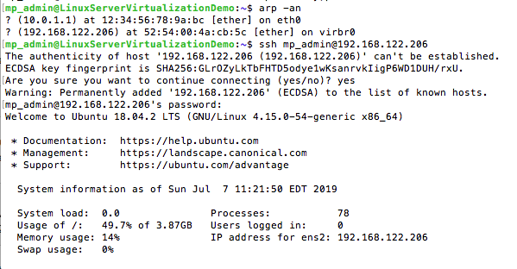

1. From here you can fix the serial console. Use nano or vi to open the /etc/default/grub for editing.



1. In the file, you can make edits where it says **GRUB_CMDLINE_LINUX_DEFAULT** and “**console=ttyS0**” at the end of the line, in quotes.

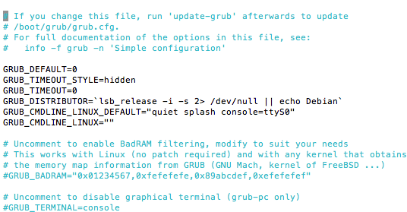

1. Save and close the file. Then run the command update-grub.

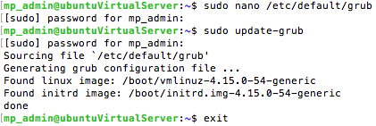

1. Exit the VM to return back to the Azure VM.



1. Restart the virtualized server with the commands virsh destroy <name of machine> and virsh start <name of machine>.

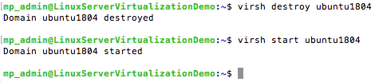

1. Once it’s running, you can now access the virtualized server through a serial console with the command virsh console <name of machine>.

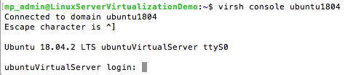

## Additional Resources

<https://www.linuxtechi.com/install-configure-kvm-ubuntu-18-04-server/>

<https://www.brianlinkletter.com/create-a-nested-virtual-machine-in-a-microsoft-azure-linux-vm/>

# Chapter 3. Microsoft Server 2016 Installation

## Before You Begin

This chapter provides instructions for deploying your server from an **onsite location**. Again, for this installation you will need a cloud hosting account. We will be using Microsoft Azure for this setup, as well. It may be a good idea to perform the following actions prior to beginning the installation:

* Double-check system specifications and adhere to the noted requirements mentioned in **Chapter 1: System Requirements**.
* Back up all data!
* Review all step-by-step installation details.

## Installation

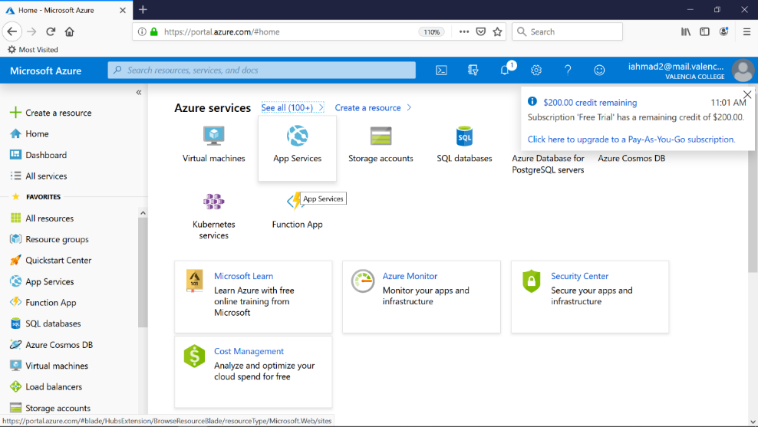

Figure 1: Left Panel has projects for Virtual Machines, Applications, and Databases

**MAIN PAGE** This is the main screen of your account once you have registered with Microsoft Azure. On the left panel are a list of options to choose from for the beginning of a new project.

**RESOURCE GROUPS** Here is where a resource can be created. A resource group tells us the location of the nearest resources that are available to you, which you are able to take full advantage of, in order to create and progress through your projects. While it is not necessary to create a resource group before starting a new project it is easier to set up your project if done initially. In addition, naming your resource groups also helps to differentiate between your projects and the specific resources you have chosen for each particular project.

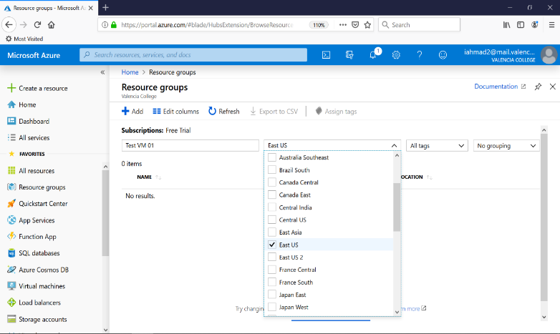

Figure 2: We have selected East US as this is the closest to your particular office.

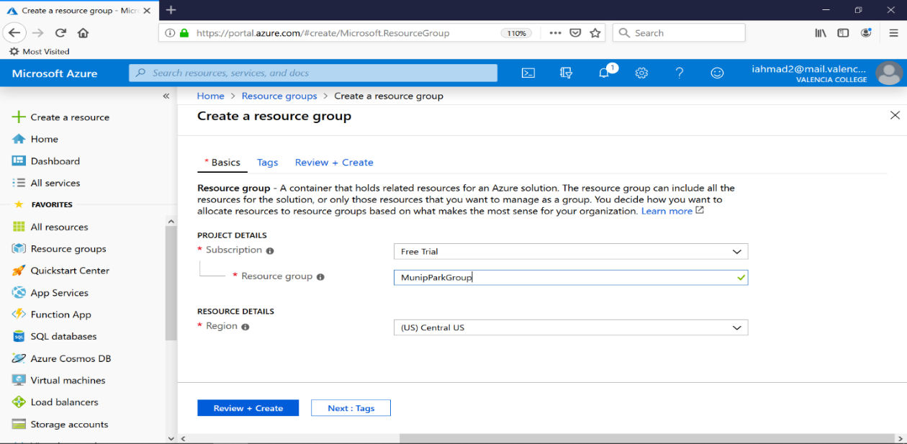

Figure 3: Naming resource groups helps to differentiate between projects as well as locations for resources.

**STEPS TO CREATE VIRTUAL MACHINE USING MICROSOFT AZURE:**

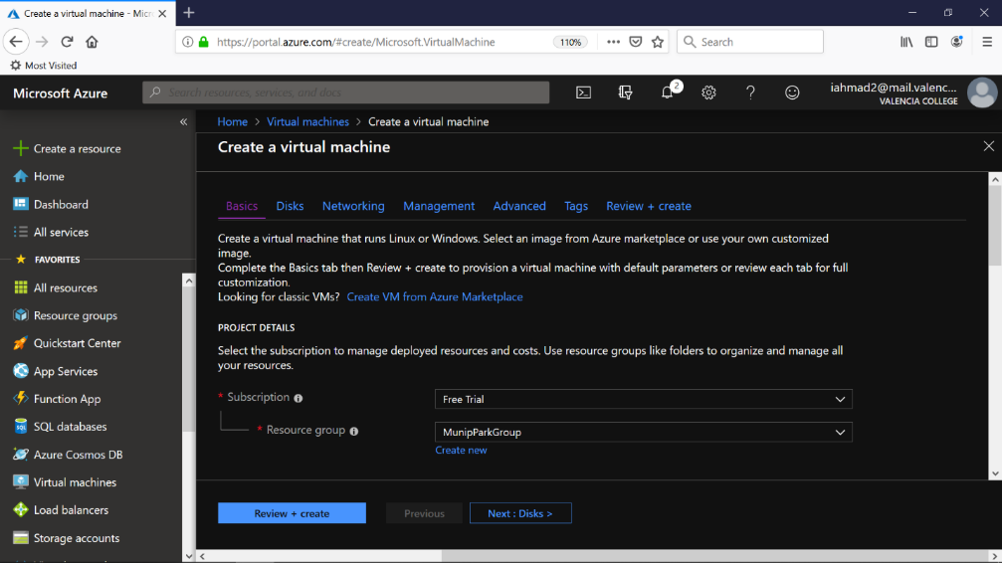

Figure 4

To begin creating a virtual machine click CREATE NEW. Choose your particular subscription, in this case we will chose the free subscription. Lastly, use the dropdown menu to choose the resource group you created earlier or make one at this point. Refer to Fig. 4.

Click ADD in the toolbar at the top of the page to begin selecting the operating system and other detail for your virtual environment. You can also do a quick search using the box at the top of your main account screen to populate options for different operating system to be used on the created virtual machines as shown by Figure 5.

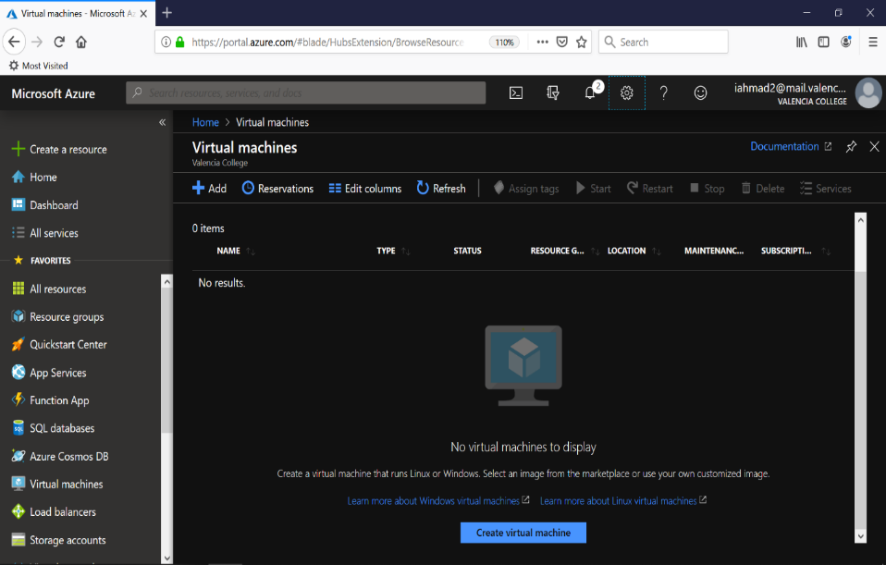

Figure 5

Next you will be selecting the type of virtual machine you will be needing for your project. This step is to be considered greatly as it will affect the day to day operations of the virtual environment. The amount of vcpus, ram, and storage all depends on the amount you are willing to pay.

Select the machine by clicking to highlight the option in which you believe would suit your needs the most. For this instance, we have chosen to use a machine that contains the following (Figure 6):

VCPU: 1

RAM: 2GB

DATA DISKS: 4

INPUT/OUTPUT OPERATIONS PER SECOND: 4X500

TEMP STORAGE SIZE: 16GB

PRICE: 43.07/MONTH

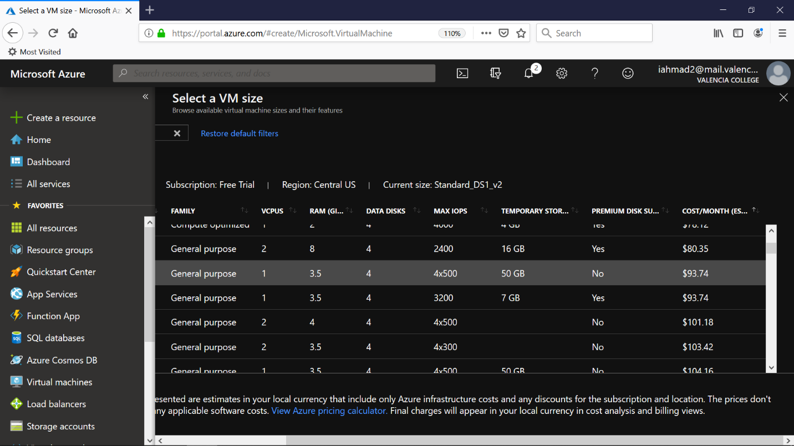

Figure 6: Selecting VM size is a crucial component in creating a virtual environment. Microsoft Azure has many options and pricing for any type of virtual environment you are wishing to create.

Next, enter the information you will be using for your virtual machine setup. This includes the operating system type, username and password. Ensure to make your password complex but something that you will remember.

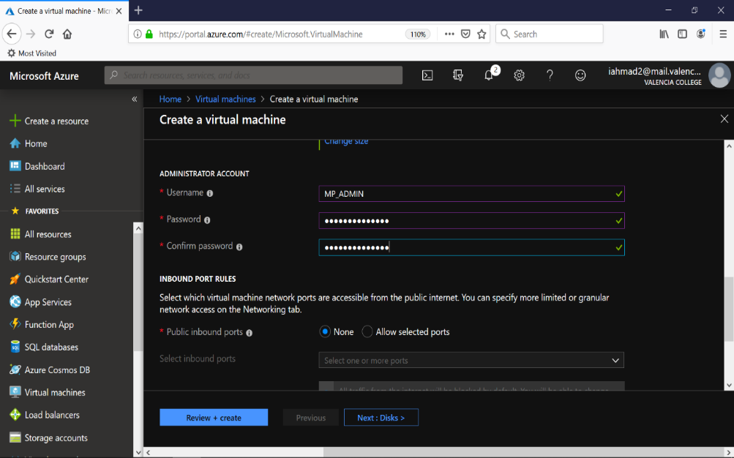

Figure 7: In our example we have set the username to MP_ADMIN and the password as MunicipalPark$.

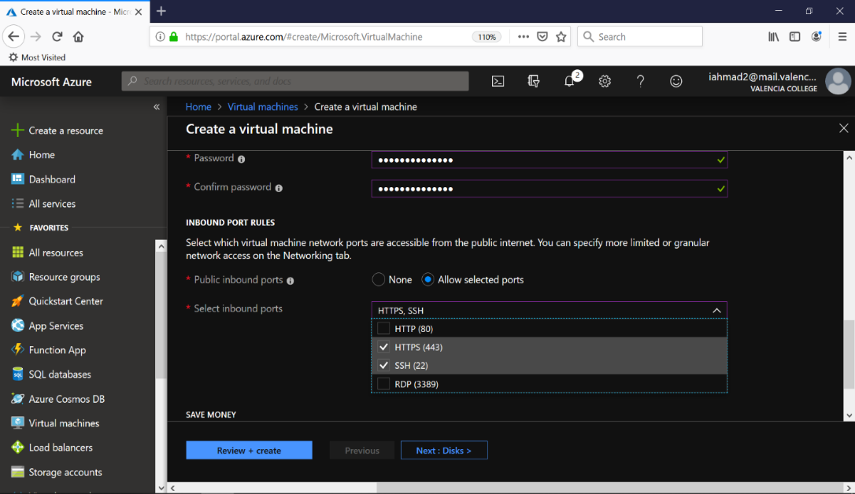

Figure 8: Setting up remote access using RDP, SSH, or HTTPS.

In order for you to be able to access the virtual machine you will need to enable such options as SSH connection, RDP (Remote Desktop), or HTTPS.

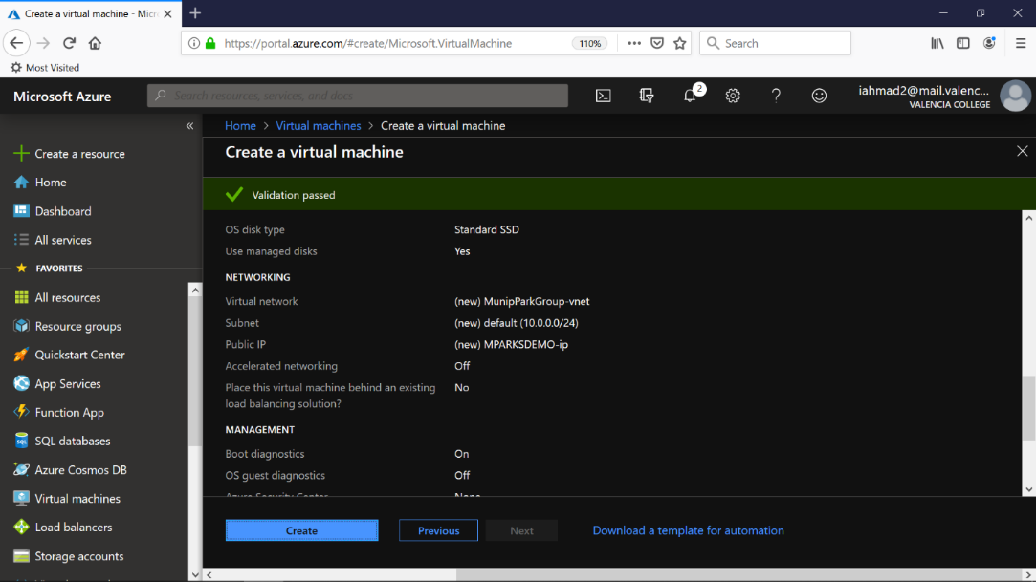

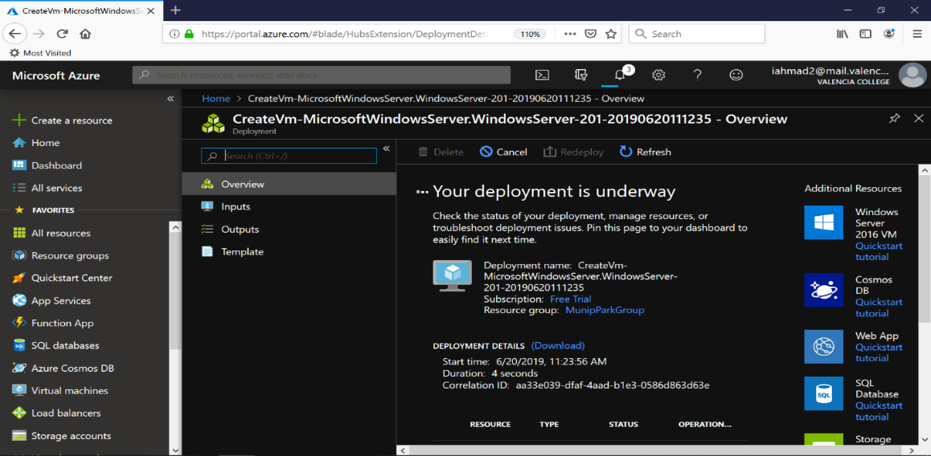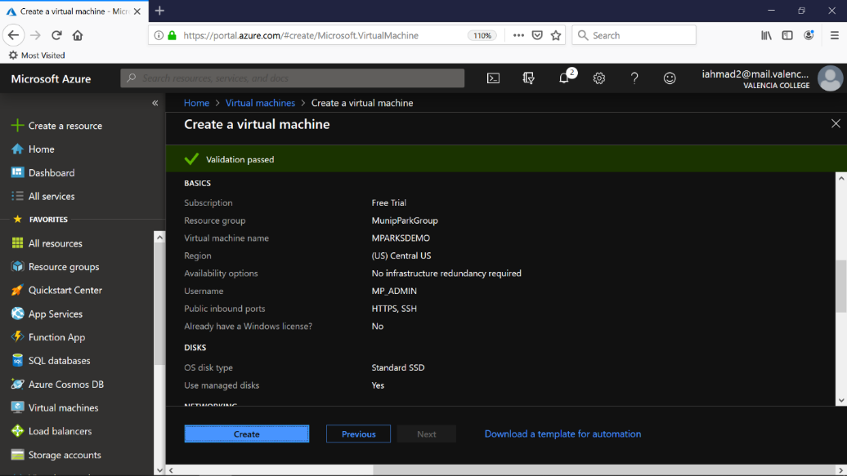

Figures 9 & 10: Review all the settings for your virtual machine.

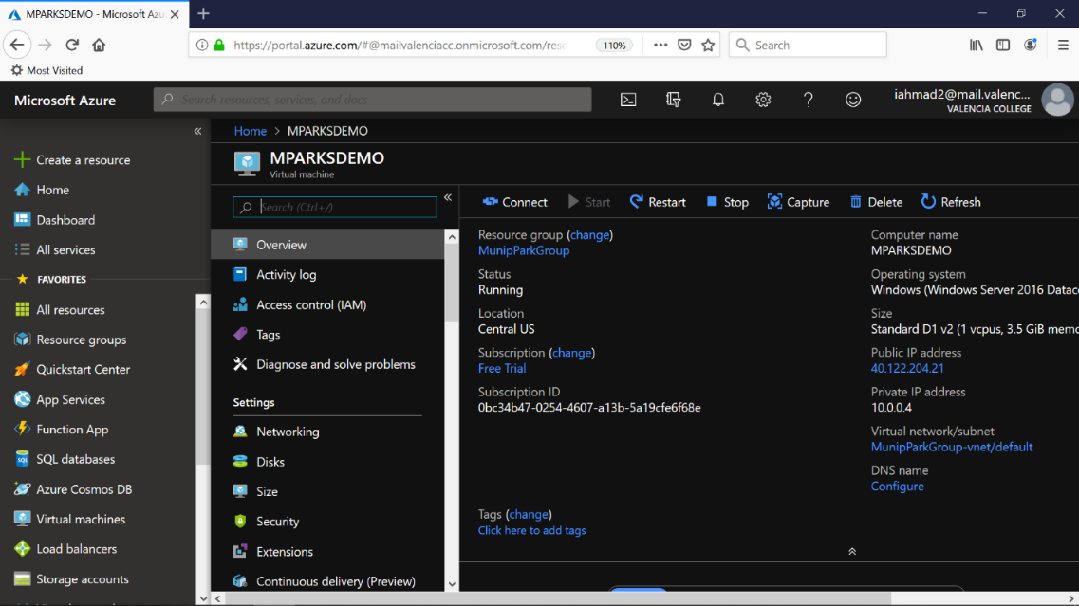

Once you have entered all the necessary information, review all your setting to ensure this is what you want your virtual machine to be. After you have reviewed all the information, click CREATE to begin the actual creation of your machine. Microsoft Azure services will take over from here and it is just a matter of waiting until the process has been finished. You will see a notification stating that the deployment is under way as shown in Figure 11.

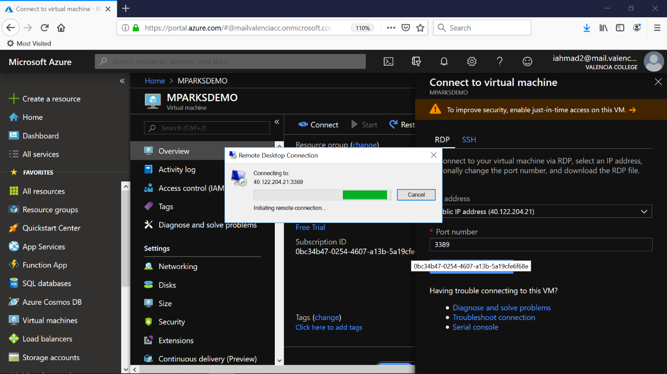

Figure 12: For our demonstration, we will be using RDP in order to connect to the virtual machine. You can see the port number that will be used for this connection so securing it in the future will be needed.

After deployment is successful, navigate to virtual machines in left pane of the window. Click on the virtual machine that you have just created. Select connect to use either RDP or another program such as Putty to SSH into the virtual machine. Figure 12.

Once connected, you will be brought to the login screen for your virtual machine. Select the user (MP_ADMIN in our case) and enter the password you created earlier.

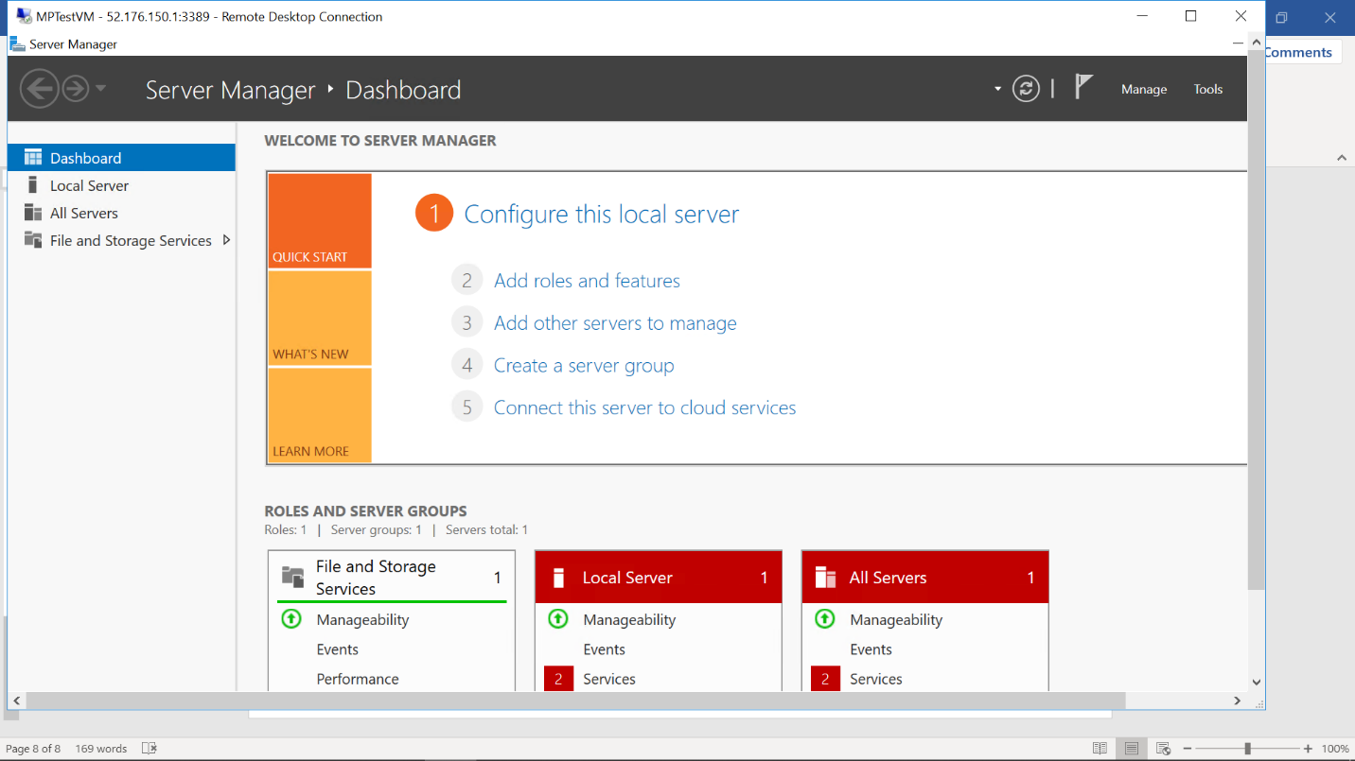

Upon successful login, Microsoft Server 2016 will load automatically in which you can begin using for your purposes. Again, setting up Microsoft Server can be rather difficult however there are services that can be provided to help with this.

In addition, overall security is very important. It is recommended to install a Security Software such as Norton to protect your machine. Below is the typical pricing for Norton Anti-virus.

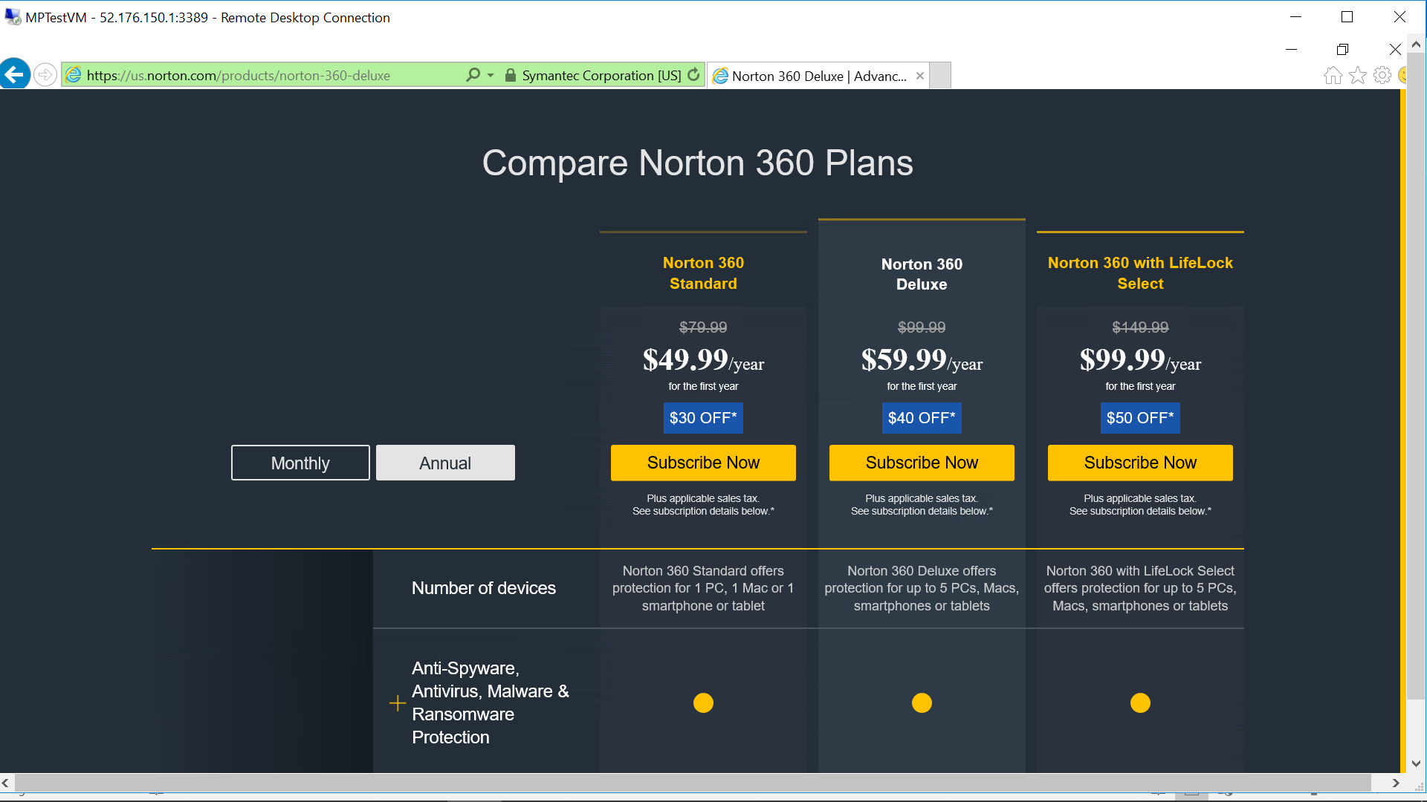

# Chapter 4. Maintenance and Security

Most day-to-day maintenance functions will be taken care of automatically, but these are the things you may want to be aware of.

## Routine and Preventative Maintenance

Routine patches will be implemented by the Windows system in which the software is being used. Linux OS may also provide updates but maybe need to be updated manually. This can be included in a scheduled maintenance package below. Antivirus software will also need updates and will prompt the user to complete this action. It is recommended to do so but can also be taken care of by our team.

## Scheduled Maintenance

Our team will offer any business we work with the option to have us come out on a scheduled that we can discuss to provide periodic updates on importance software and hardware. This includes OS updates, system backups, hardware upgrades, and anything else we may suggest to keep your system running.

## Increased Security

We have decided to offer the services of ThreatLocker as an added security measure with our servers. They offer more than just an antivirus they are here to protect large businesses or schools or anything within that nature from forms of malware or even users running software that is unwanted. We can take complete control using something like ThreatLocker.